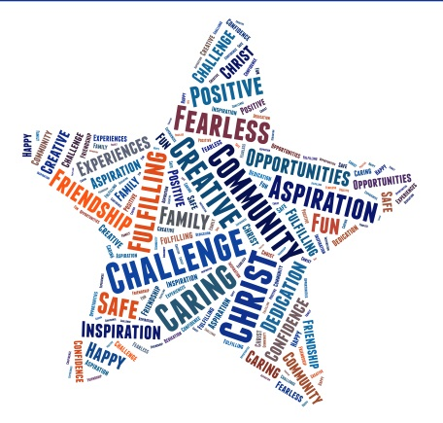
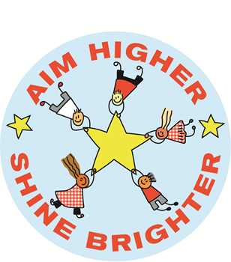

Wath C. of E. Primary School

British Values Policy 2019/20

Agreed by the Governing Body on

Review Date

Review Schedule
Annual / Biennial / Termly
Person(s) Responsible
Curriculum Team Subject Leader

Purpose

At Wath C of E Primary School we uphold and teach pupils about British Values which are defined as:

- democracy
- rule of law
- individual liberty
- mutual respect
- tolerance of those of different faiths and beliefs

Aims

These values are taught explicitly through Personal, Social, Health and Emotional (PSHE), and Religious Education (RE). We also teach British Values through planning and delivering a broad and balanced curriculum.

The school takes opportunities to actively promote British Values through daily collective worship and whole school systems and structures such as electing and running a highly successful school council. We also actively promote British values through ensuring that our curriculum planning and delivery includes real opportunities for exploring these values. Our Tuesday Curriculum Ambassadors Assemblies are attended by parents who are then able to promote our core values and participate in discussions surrounding them with their children.

Teaching and Learning

At Wath C of E Primary School, these values are reinforced regularly and in the following ways:

Democracy:
At Wath C of E Primary School, democracy is promoted from when the children start school in September. Each year, the children through pupil voice share their thoughts on our rewards policy. Children have many opportunities for their voices to be heard. Throughout the first half term, children vote for their school council, sports council, eco warriors as well as the worship council. Each year, candidates interested are able to put their name forward and the class will hold an election to decide who will represent the class in the areas mentioned. All committees play an important role within school and have made fantastic changes around school, some of which are extremely visible and providing lasting achievements.

The Rule of Law:
The importance of laws and rules, whether they are those that govern the class, the school or the country, are consistently reinforced throughout regular school days. Our ladder and Class Dojo system for reinforcing positive behaviour is used consistently throughout school. Children are familiar with rewards, why they are given and consequences are explained in relation to the school rules. The children, along with parents and staff, have helped shape our new behaviour system which is based on three behaviours of fantastic walking, focused listening and kindness. These behaviours are modelled by staff and celebrated when children reach expected behaviour but particularly when they go over and above. This is done through recognition boards, notes home and Hot Chocolate Heroes which is held every Friday with the Headteacher and where a nominated pupil from each class describes how they have gone over and above in a certain area. Regular pupil voice and parent feedback ensures the rules are under constant review.

Children are encouraged to make connections between behaviour, rewards and consequences. Pupils are taught the value and reasons behind rules, that they govern and protect us, the responsibilities that this involves and the consequences when laws are broken. Visits from authorities such as the police, fire service etc. are regular parts of our calendar and help reinforce this message.

To encourage and promote good behaviour, attitude and work, we have devised a reward system which is consistently followed throughout the school. We are committed to praising children’s efforts. We endeavour to praise the children informally, individually, during group work, in front of the whole class and the whole school. Children are rewarded not only for achievement in curriculum areas, but for behaviour and general adherence to our school rules and ‘Aim Higher, Shine Brighter’ motto.

Individual Liberty:
Pupils are actively encouraged to make choices at our school, knowing that they are in a safe and supportive environment. As a school we provide boundaries for our children to make choices safely, through the provision of a safe environment and planned curriculum. Pupils are encouraged to know, understand and exercise their rights and personal freedoms and are advised how to exercise these safely, for example through our e-Safety teaching. Pupils are given the freedom to make choices, e.g. signing up for extra-curricular clubs. The school provide a range of opportunities for children to make healthy life style choices through playtime snacks, active playtimes, fit in fifteen activities and the science curriculum.

Mutual Respect:
Children learn that their behaviours have an effect on their own rights and those of others. Children are aware of their behaviour through kindness being one of the three core behaviours we model in school. We bring awareness to causes such as Anti-Bullying week to reinforce the important of mutual respect and understanding. Last year we achieved Anti-Bullying Silver Status and we are working towards gold this year. We encourage children to focus ‘telling’ as the first step to resolving any such matter. All members of the school community treat each other with respect. Part of our school ethos and behaviour policy are based around core Christian values including: love, hope, peace and joy. These values determine how we live as a community at Wath C of E Primary School. Collective Worship is based on these Christian Values which are central to how we expect everyone to go about their life at our school. We encourage children to use these skills to make themselves more effective learners and to ensure they are contributing to both the class and school as a whole. Each week we celebrate the learning of curriculum ambassadors across school, focusing on a particular curriculum area. We also take part in Downs Syndrome Day and Wear Red for Children’s Heart Surgery so that our children are aware of differences amongst our own school community and the challenges some children face. One project celebration per term is socially useful so that the children understand their actions can make a real difference.

Tolerance of those of Different Faiths and Beliefs:
This is achieved through enhancing pupils’ understanding of their place in a culturally diverse society and by giving them opportunities to experience such diversity in our local community which is largely white British. Collective Worship and discussions involving prejudices and prejudice-based bullying have been followed and supported by learning in RE and PSHE. We invite guest speakers and run workshops to give the children a real experience of a different belief system.

Planning

Staff plan for a range of opportunities to explore British Values through topic based learning as well as PSHE and RE lessons. Curriculum Maps are then analysed to ensure breadth of coverage. These Curriculum Maps are then shared through our school website.

Date: October 2019

School British Values Opportunities

 | Democracy | The Rule of Law | Individual  Liberty | Mutual Respect | Tolerance
Whole school | - Voting for school council.  - Voting for sports council.  - Voting for eco warriors.  - Voting for worship committee members.  - Each group meets at least every regularly to discuss and decide on matters linked to the action plan.  - Whole school assembly16.09.19 democracy. | - Whole school assembly30.09.19 rule of law.  - The school behaviour focused on celebrating three behaviours; fantastic walking, focused listening and kindness. | - Whole school assembly 14.10.19 being safe at school.  - The growth mindset driver in school where the children decide on ways of thinking to support their learning. These include; effort, resilience, what to do if you are stuck, the magic of mistake and enjoying challenges.  - E-safety week. | - Whole school assembly18.09.19 bullying.  - Whole school assembly 02.10.19 patience.  - Whole school assembly 09.10.19 forgiveness.  - Anti-Bullying Silver Award achieved 2018/19 and working towards Gold for 2019/20.  - Playground buddies from Y5/6. | - Whole school assembly 14.10.19.  - The Rotherham Agreed Syllabus which we use to teach RE is based on the major world faiths with the children learning about and from these faiths.  - Participating in borough-wide sporting opportunities.
EYFS | As part of our daily set up in EYFS, children are taught individual liberty through self-selecting in the indoor and outdoor environment. The value of democracy is taught through collaborative decision making such as deciding how to set up the role-play area. Curriculum planning is influenced by following children’s interests to engage them in their learning. Children learn about the rule of law by understanding and cooperating with school rules and class routines. They learn to share and cooperate with each other while they play. Tolerance is taught through understanding the world.
Y1 | The children study mutual respect in their PHSE learning around friendship, keeping myself safe through e-safety [individual liberty] and democracy through voting for their favourite story for the adult to read each day from two possible choices.
Y2 | During Year 2, children learn about mutual respect in their work around ice-caps in geography and plastic waste in their science focused project, ‘Is the sea alive?’ In the RE curriculum, the children study belonging to a community [tolerance] and being fair [rule of law]. In addition to this, in PHSE, the children study keeping myself safe [individual liberty] and me, my community and the environment [tolerance].
Y3 | In the class novel Ug Boy Genius of the Stone Age, the children explore individual liberty as UG struggles to get his community to accept new ideas from a boy. Through RE, the children understand tolerance in discussing Hindu beliefs and mutual respect in what makes Jesus an inspirational person. In PHSE, they revisit all the British Values.
Y4 | In Year 4, the children develop tolerance through the study of Chinese Culture and well as individual liberty through the study of unhealthy lifestyles in science. Through the class novel in the Spring Term, which is Podkin One Ear, the children learn about individual liberty, mutual respect and tolerance. In their RE learning, the children learn about Christian Values [mutual respect] and religions pilgrimages [tolerance]. When investigating PHSE, the children learn about respecting differences [tolerance], environmental sustainability [mutual respect], E safety [individual liberty] and how rules affect me [rule of law].
Y5 | In Year 5, the children study the USA in geography to consider individual liberty and the rule of law. This is also considered in Viking history. In RE, the children study the five pillars of Islam [tolerance] and how Christians use the Bible [rule of law]. Through PHSE, the children explore conflict resolution [rule of law], e-safety [individual liberty] and transition [mutual respect].
Y6 | Through the India geography topic, the children learn tolerance through the story Broken Glass. Whilst later in the year in science, the children learn about individual liberty through the healthy lifestyle topic and making independent, informed, healthy choices. In the WW2 topic, the children learn about tolerance and mutual respect and this is further reinforced by RE themes of inspiring Muslims and Christians, Islamic Relief and Christian Aid and Respect and the community. PHSE explores a range of British Values themes through responsibilities [individual liberty], relationships [mutual respect], global citizen [tolerance] and world of drugs [rule of law]. The visit to Crucial Crew reinforces the rule of law and tolerance through a range of real life scenarios.

