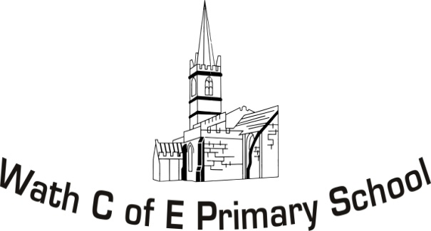
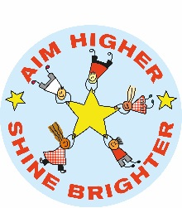
Year 6 Curriculum Map 2020-21

 | Autumn 1 | Autumn 2 | Spring 1 | Spring 2 | Summer 1 | Summer 2
Topic | War – A Necessary Evil? (history focus WW1 and WW2) | War – A Necessary Evil? (history focus WW1 and WW2) | Are all countries the same? An Indian study (Geography focus) | Are all countries the same? An Indian study (Geography focus) | Change – Friend or Foe? (DT and art focus) | Change – Friend or Foe? (DT and art focus)
English | Sentence structures (week 1-2)  Recounts (week 3-5)  Explanation (week 6-8) | Instructions (weeks 1-3)  Descriptive writing (weeks 4-6)  Poetry (week 7) | Newspaper report (weeks 1-3)  -Global weather emergencies  Biography (weeks 4-6) | Narrative (weeks 1-3)  Persuasion (weeks 4-6)  -deforestation | Formal letters (weeks 1-2)  Informal letters (weeks 3 and 5) | Formal and informal non chronological reports (weeks 1-4)  Balanced arguments (weeks 5-7)
SPaG | - Tenses (past, present, future, progressive and perfect)  - Adverb(ial)s | - Complex lists.  - Expanded noun phrases.  - Hyphens  - Prepositional phrases  - Relative clauses  - Parenthesis | - Phrases and clauses  - Subordinate clauses  - Coordinating conjunctions  - Direct and reported speech | - Questions, statements, commands and exclamations.  - Modal verbs  - Semi colons  - Dashes  - Apostrophes | - Colons  - Active and passive voice  - Subjunctive form  - Commas for clarity | - Applying consistently through writing.
Class Texts | Letters from the Lighthouse |  | Broken Glass by Sally Grindley |  | If the World were a Village
Mathematics | Place value  Ordering  Rounding  Calculation methods for addition, subtraction, multiplication and division  Negative numbers | Calculation methods  Word problems  Fractions  Graphs  Data handling | Fractions  Decimals  Percentages  Algebra  Measures (conversions)  Time  Angles, area, volume | Ratio  Statistics  Problem solving  Angles  Co-ordinates  Formula  Algebra  Data handling | Word and real-life problems.  All operations  Mixed fractions, decimals and percentages.  Shape | Puzzles, investigations and problem solving.  Enterprise
Science | Light & Shadow (topic links)  Understanding that light travels in straight lines and that we see objects because they give out or reflect light into the eyes.  Understanding the shape of shadows and how their size is affected by the position of the light source.  Topic links - night combat, black outs, and periscopes. | Circuits & Electricity  To identify the basic parts of an electrical circuit.  To understand how the number and voltage of cells can affect the other components.  To give reasons for variations in how components function. | Evolution & Adaptation (topic links)  Understanding why offspring vary and are not identical to their parents.  Describing how adaptation leads to evaluation.  Recognising why the human skeleton has changed over time.  Topic – how animals adapt to the various climates and weather conditions in India. | Classification including micro-organisms  Describing how living things are classified.  Giving reasons for classifying plants and animals based on specific characteristics. | Animals including humans (topic driver)  Recognising the impact of diet, exercise, drugs and lifestyle on the way the body functions.  Identifying the main parts of the circulatory system and explaining the functions of the heart, blood vessels and blood.  Supporting others to lead active and healthy lifestyles by planning and running intra-school events.
Humanities | ‘War – a necessary evil?’ (history led)  To build an overview of world history.  To form a clear overview of the previous areas of history studied and of the local area.  To understand chronology and continuity and change.  To understand aspects of continuity and change over time particularly in relation to war.  To identify periods of little change within the war and contrast them with periods of rapid change.  To understand propaganda and forming testable hypotheses about the past.  To explore war propaganda and use it to draw hypotheses about key events.  To understand the significance of events.  To research and reflect on the significance of key battles in WW2. |  | Are all countries the same? An Indian study (geography led)  To investigate places  To locate countries and cities of the world and identify their human and physical features.  To use geographical resources to compare and draw conclusions about locations.  To use a knowledge of time zones to plan a journey.  To investigate patterns.  To understand how countries are interdependent and interconnected.  To understand why some locations are changing.  To describe geographical diversity.  To communicate geographically  To accurately use 8 compass points and 6-figure grid references to describe locations.  To communicate the impact of the equator and lines of Capricorn and Cancer on the climate. |  | Change – friend or for? (art and DT led)  Sculpture and textiles  To comment on the style of notable designers (an artist study of Keith Harding and Giacometti.  To combine elements of design from a range of inspirational designers with a service in mind.  To join textiles with a combination of stitching techniques, ensuring products have a high quality finish.  To show life-like qualities.  To use frameworks to provide stability and form.  To create original products that use the qualities of materials to enhance ideas and improve upon the prototypes.
Art and DT | Drawing (linked to creating war pictures)  To use a choice of techniques (including lines) to depict movement.  To use a choice of techniques to depict shadows.  To use a choice of techniques to depict perspective.  Painting (linked to creating poppy Christmas cards)  To create a colour palette based on colours observed in the natural world.  To use brush techniques and the qualities of paint to create texture.  To use the qualities of watercolour and acrylic paints to create visually interesting  pieces.  Electricals and electronics  To create circuits (see science). |  | Collage (linked to Indian Rangoli designs)  To collect information and present ideas in a sketch book.  To mix textures.  To use ceramic materials and techniques.  To combine visual and tactile qualities.  Food (linked to making Indian food)  To understand the importance of the correct storage and handling of ingredients.  To measure accurately and scale recipes up and down  To demonstrate a range of cooking and baking techniques.  Computing  To use code to control and monitor models or products (see ICT)
RE | Inspirational People – Muslims & Christians. Linked to the topic by looking at inspirational war figures. |  | Islamic Relief & Christian Aid. Linked to the topic through their work in India. |  | Respect & Community – What will make Rotherham a more respectful and peaceful place? Linked to the changes they may experience in their transition to secondary school.
PHSCE | The Caring School | Relationships | Responsibilities | Safety  Age restrictions  Negative internet uses  Recognising abuse & reporting it | World of Drugs | Ups and downs of puberty
PE | Invasion Games  Gymnastics |  | Striking & fielding  Dance |  | Athletics  Net/ Wall
Spanish | The weather  Seasons  Describing a scene (geography)  Spanish culture and celebrations
Music | Using standard notation on the treble and bass clefs including flats and sharp.  Appraising including the terms: Pitch, dynamics, tempo, timbre, texture, lyrics and melody expressive, sense of occasion, accompaniments, cultural context, combination of musical elements  Performance and composition
ICT | Using Modkit to create, design and write code in Robot C (Text based code) to program a robot to fulfil a goal set out on a robotics field.  Design and write a program in Python to perform calculations and print words.  Work collaboratively online to create and 3D print an attachment for the robot.  Manipulate HTML code to show how it can be changed and mis-respresented.
Hook/Celebration | Hook - historical walk of Wath to set the scene of the locality during the world wars and visiting the war memorial to learn some of the stories behind the names.  Celebration - a play for parents to demonstrate some of the historical learning and a traditional games session. |  | Hook – cooking Indian food to mark Vasant Panchami – a festival that marks the beginning of the end of winter.  Celebration - family geography quiz and display of Rangoli designs outside the classroom. |  | Hook - A dance, drama and photography day on portraying and capturing different emotions.  Celebration - children leading a wire/foil modelling session for their parents.

