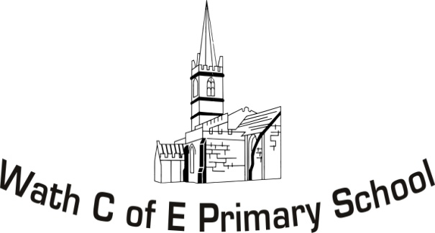
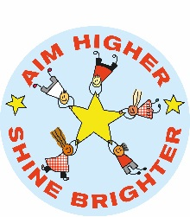
Year 5 Curriculum Map

 | Autumn 1 | Autumn 2 | Spring 1 | Spring 2 | Summer 1 | Summer 2
Topic | History: Vikings and Roman Empire  – ‘Is war glorious?’ |  | Geography: The United States of America and U.K.  – Is freedom really free? |  | Science: Space  – ‘Are we alone in the universe?’
English | Diary entry: X 2  A day in the life of a Roman Legionnaire.  SPAG focus MS  Roman Empire Non-Chron | Instructions: X2  How to forge a mythical weapon.  Reading and writing Norse myths.  Narrative: X3:  Quest stories. | Newspaper Report Based on the crimes committed by ‘The Outlaw’, who is embarking upon criminal escapades around Wath C of E.  Description (Hook)  WANTED Posters.  Persuasive writing/debate.  Hunt ‘The Outlaw’, try him/her and sentence them for their crime. (rule of law). | Poetry:  Haikus and rap.  Non-Chron:  Travel guide to the USA.  Script Writing  Children to take on the roles of directors writing a Hollywood Blockbuster’s script. | Setting descriptions:  Description of new planet created by the children.  Character Description:  Creation of an alien race.  Cosmic Records:  Launch record into the community. | Biographies:  Neil Armstrong or Werner Von Braun  Explanation:  From an alien perspective, children to explain why aliens would venture to earth.
Class Novel | Who Let the Gods Out?  Weekly Roman Myth to be studied. | Viking Boy.  Weekly Norse Myth to be studied. | The Infinite Lives Of Maisy Day  (GR) Clockwork
Mathematics | Place Value x4  Addition and Subtraction x4 | Multiplication and division x6  Fractions x1 | Fractions (cont) x4  Decimals x1 | Decimals and percentages x4  Money x1 | Time x1  Measure x 2  Handling data x1  Angles x 2 | Shape x2  Position and direction x 2  Revisit
Science | Properties and changes of materials.  Mixtures and solutions. | Forces  (Buoyancy) | Living things and their habitats. | Properties and changes of materials.  (Changing states) | Earth and Space | Forces  (Gravity)
ICT | Introduction to Scratch | Developing coding | Kodu and using conditions to control |  | Using sensing tools | Modkit and programming robots.
Humanities | Roman Empire, Vikings, Anglo-Saxons and the Danelaw. |  | Great Britain, comparison between the U.K. and another European nation, and the United States of America. |  | History of Space Travel | The Space Race
Art and DT | 3D Weapon art (Smiting Roman shields and Viking weaponry) .  Shield art (paint)  Sketches of Gods and Goddesses | Creation of effigies and idols (clay)  Viking broaches. | Design E-fit from descriptions.  American cookery. | Construction of motor vehicles.  Banksy street art. | Solar system (chalk)  Alien planet scenery. | Nebula pointillism.  Create functional rocket.
RE | Islam |  | Justice and Freedom |  | Christianity
PHSCE | Conflict resolution and mediation. | Bullying [pressures and risks] | Emotional wellbeing. | Careers and the world of work. | E-safety | Transition
PE | Gymnastics/Dance | Outdoor Adventurous (Orienteering) | Invasion games  (Tag Rugby) | Athletics  (Beating personal bests) | Invasion Games.  (Hockey or football) | Striking and Fielding Games.  (Rounders)
Spanish | Description | Likes and dislikes | Preferences and hobbies. | School life (Routine and equipment) | Using a dictionary | Topic related – Space
Music | Harvest Songs | Instruments | American songs  (Star Spangled Banner, country music and rap)  Songs to be used through GR. |  | The sounds of space. | School concert
Hook/Celebration | Vikings  ‘Is war glorious?’  MO1 – Visitor.  MO2 – Creating runic Jewellery/talismans) SELL (enterprise link).  FINAL OUTCOME:  Dragon Boat race? |  | U.S.A  ‘Is freedom really free?’  MO1 – Catch an Outlaw. (Western themed)  MO2 – Super bowl.  FINAL OUTCOME:  Oscars event.  Parents in. |  | Space  ‘Are we alone in the universe?’  MO1 – Build a rover.  MO2 – Space centre.  MO3 – Balloon launch helium.  FINAL OUTCOME:  Cosmic Record?

