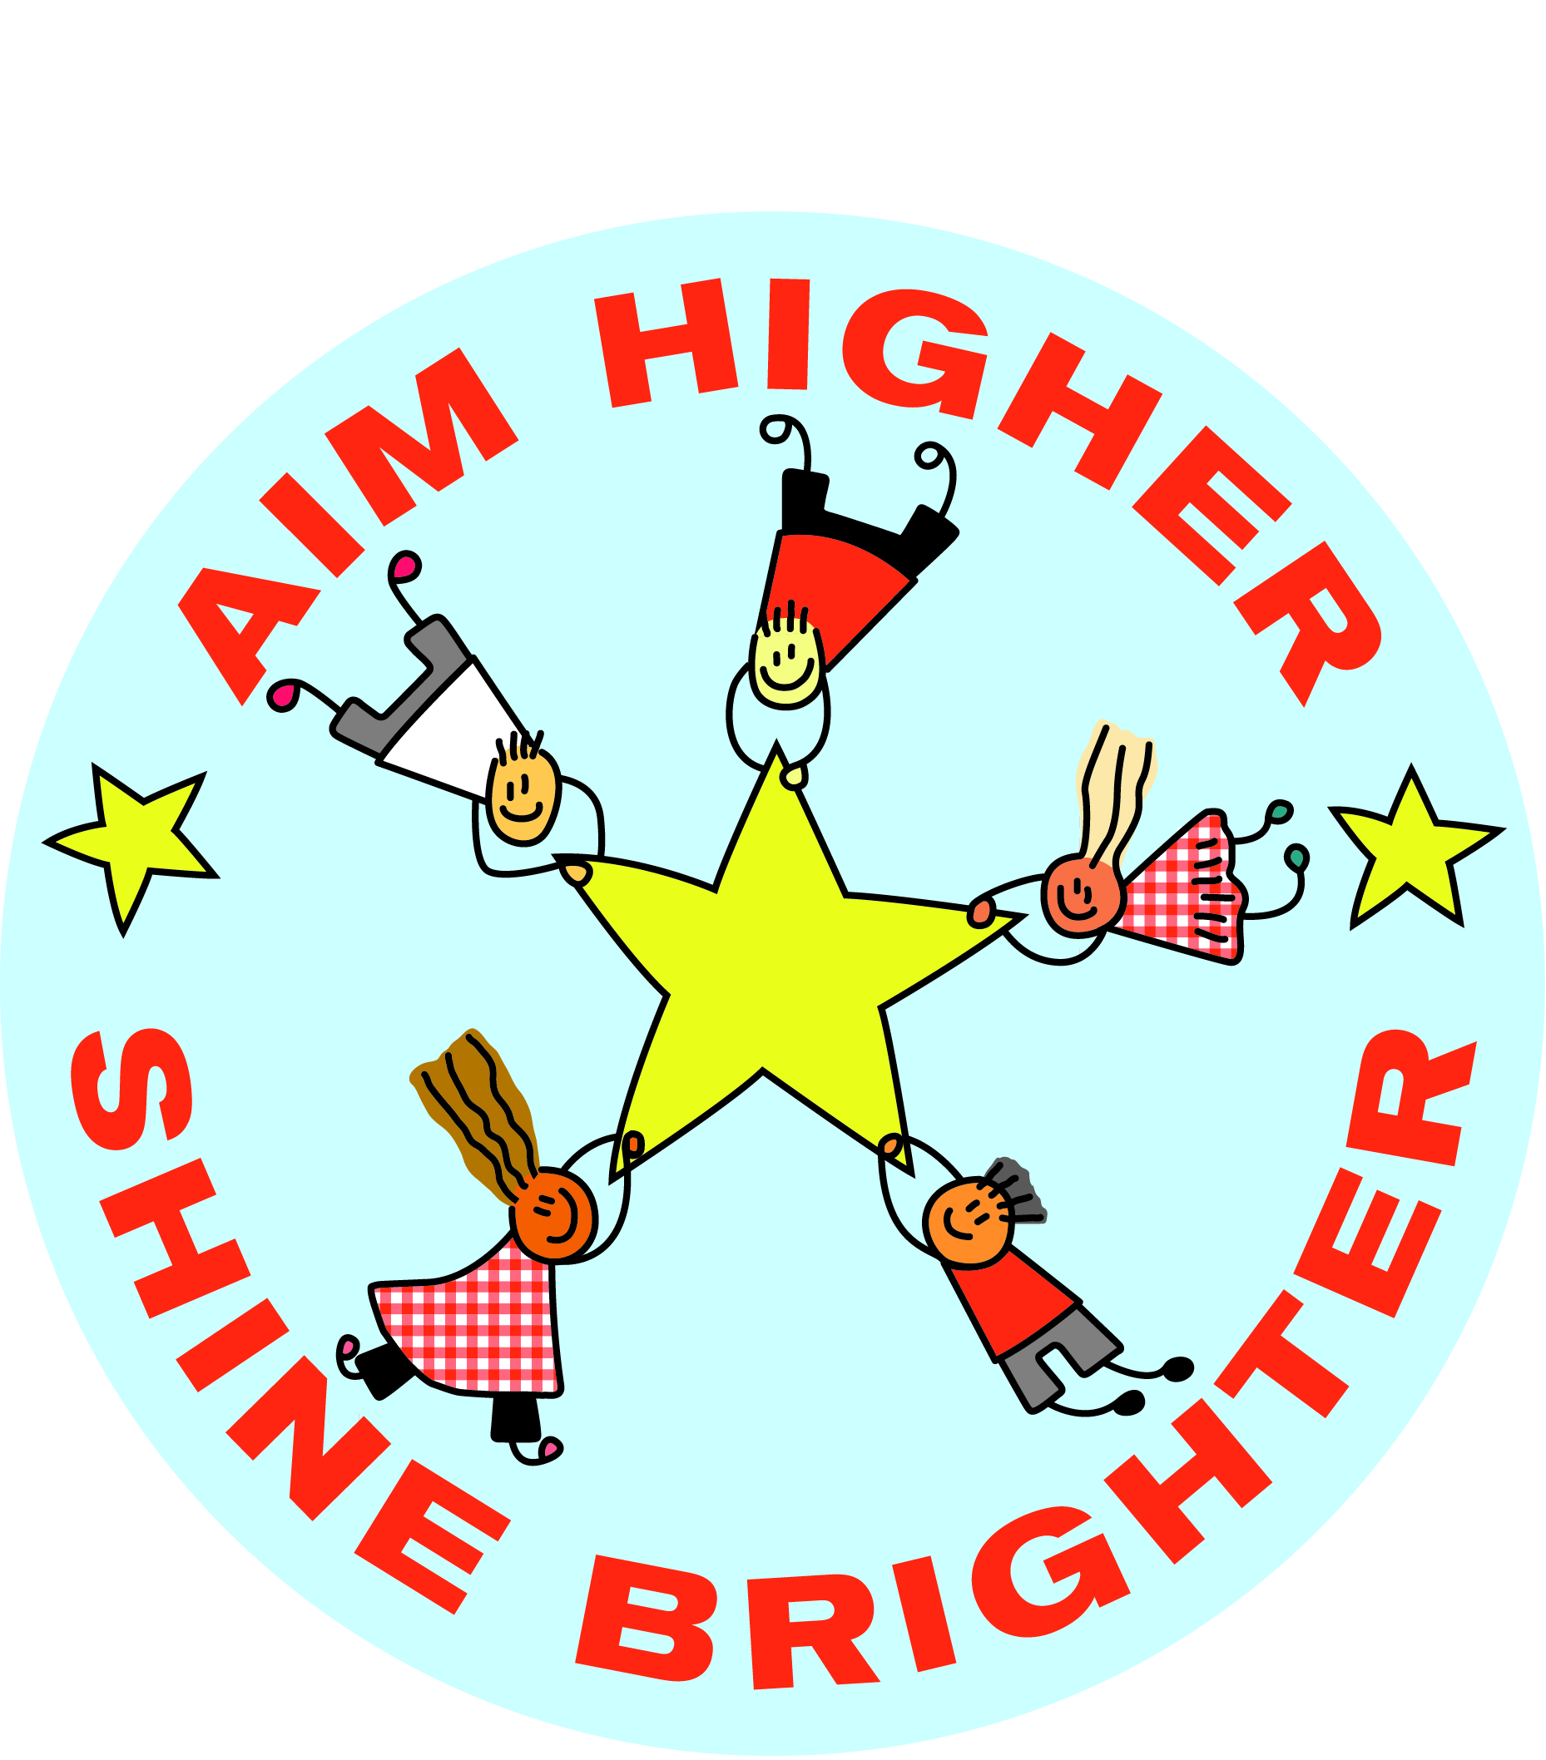
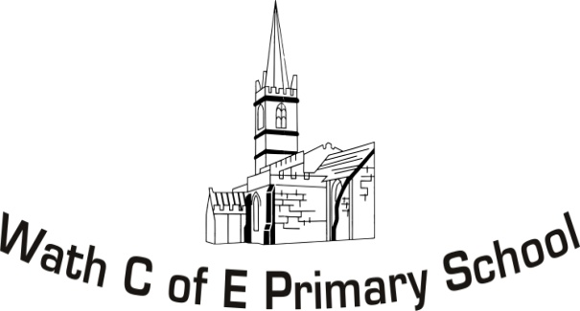
Year 4 Curriculum 2019-20

 | Autumn 1 |  | Autumn 2 | Spring 1 | Spring 2 |  | Summer 1 | Summer 2
Project Theme | History: Ancient Egypt |  |  | Geography: Asia (and comparisons to the UK) |  | Science: Healthy Lifestyles
English | Sentence Structure.  Diary Writing- living in Ancient Egypt  Instruction Writing- mummification |  | Newspaper Reports- discovering something from Egypt  Narrative- life as an Egyptian person. | Story writing/traditional tales based on different locations.  Balanced Arguments. | Persuasive writing- visiting Asia  Poetry- linked to China/Japan  Description- setting/character |  | Explanation writing- how to brush your teeth, how to live a healthy lifestyle.  Debate: Should healthy food be cheaper? | Information Text: The Dangers of an unhealthy lifestyle.  Persuasion (video): Prompting the final outcome event.
Class Novel | Secrets of a Sun King  The Time Travelling Cat and the Egyptian Goddess. |  |  | Podkin One Ear  Krindlekrax |  |  | Charlie and the chocolate factory.  Demon Dentist  Sweet Pizza
Mathematics | Mental strategies  Place value  Rounding  Number calculations + - and x  Properties of number  Roman Numerals  Negative Numbers |  | Mental strategies  Times tables  Multiplication  Factor pairs  Formal multiplication  Understanding hundredths | Mental strategies  Equivalent Fractions  Simplifying fractions  Adding and subtracting fractions with the same denominator  Decimal equivalent of specific fractions | Mental strategies  Dividing by 10/100  Rounding decimals  Comparing decimals with up to 2 dp  Convert between units of measure  Compare/calculate using money/different measures |  | Mental strategies  Calculate perimeter rectilinear shapes  Find the area of shapes by counting squares  Convert between units of measure Including time  Present data in graphs.  Interpret data  Identify different types of angles  Compare angles  Compare shapes based on their properties  Complete symmetric figures | Mental Strategies  Describe positions of shapes in a grid  Describe movements of shapes after translations  Plot points on a grid  Complete shapes on a grid
Science | Living Things and their habitats |  |  | Sound | Electricity  Making a circuit |  | Animals, including humans | States of Matter
ICT | To use input devices (Keyboards, mouse) to create an output. |  |  | To create digital art by using outputs. |  |  | To interact and explore uses of technology.
Humanities | History  Ancient Egypt |  |  | Geography  China |  |  | Health and Welling  Digestive system
Art and DT | Clay models of grave goods. |  | Using hieroglyphics  Landscape Art  Scarab Beetles | Cherry Blossoms | Based on the Chinese New Year  Chinese Lanterns  Chinese Plates |  | 3D fruit art  Human Heart life size model (Art Attack) | Posters for event  Mosaic
RE | Christian Values |  |  | World Religions and their pilgrimages. |  |  | Christian and Hindu answers to questions
PHSCE | Feelings, friends and friendship |  | Respecting differences | Environmental sustainability | E safety |  | How do rules and laws affect me? | The world of drugs
PE | Dance  Gymnastics |  | Dance  Gymnastics | Invasion Games  Athletics | Invasion Games  Athletics |  | Striking & Fielding  Outdoor Athletics | Striking & Fielding  Outdoor Athletics
Spanish | Family |  |  | Food |  |  | Likes and dislikes | Spanish culture and celebrations
Music | Ukulele  Appraising including the terms: timbre, texture and use of silence to describe music.  Note recognition including chords.  Ukulele First Access
Hook/Celebration | Hook – Themed Launch Day | Celebration - Museum at Library |  | Hook - Visit from local community | Celebration – Chinese New Year Celebration |  | Hook - Visit to Tesco/Pizza Express to learn about healthy eating | Celebration – Sponsored Colour Run

